Step 1: Determine the best method to address your issue.

You should first attempt to resolve problems using the chain of command and other local resources.
Seek assistance from the legal staff, union representative, chaplain, human resource personnel, equal opportunity advisor, your immediate supervisor, or Commanding Officer.
Review the list of Common Complaints on the Hotline Complaints link on our website to determine whether an established process or grievance procedure is available to address your issue.
Review the following List of Matters Appropriate for the Inspector General:
- Abuse of Authority/Position
- Bribes/Kickbacks/Acceptance of Gratuities
- Conflicts of Interests
- Ethics Violations
- Fraud/ Travel Fraud (TDY and TAD)
- Gifts (Improper)
- Improper Referral for Mental Health Evals
- Mismanagement (Significant Cases)
- Misuse of Official Time, Gov’t Property, Position and Public Office
- Political Activities
- Procurement Issues
- Purchase Card/Travel Card Abuse
- Reprisal (Military Whistleblower Protection)
- Safety/Public Health (Substantial/Specific)
- Systemic Problems
- Time and Attendance (Significant Violations)
- Waste (Gross)

Step 2: Review the Frequently Asked Questions (FAQs).

Who may use the Hotline?
Anyone can file a hotline complaint.
Is there a time limit to file a complaint?
Generally, you should submit your complaint within 90 days of the date the alleged wrongdoing occurred. However, we will consider complaints over 90 days old if you can demonstrate you were unable to meet the time requirement due to extraordinary circumstances or unforeseen delays.

What issues should you report to the Hotline?
You should report any issue listed in the List of Matters Appropriate for the IG to your local IG or installation/command IG point of contact. Report minor violations to your chain of command.
(Note: We reserve the right to decline to investigate any matter brought to our attention.)

Can I remain anonymous or request confidentiality?
You may remain anonymous, but we will not be able to contact you for more information.
You may request confidentiality, and the IG will make every effort to prevent disclosure of your identity, but we cannot guarantee confidentiality.
Step 2: Review the FAQs. (Continued)

How do you submit a hotline complaint?

We encourage you to submit the allegation(s) in writing by e-mail, fax, letter, or using the online complaint form. Our experience has shown that written complaints are more organized, provide more details and are less emotional.

How do you determine the status of your investigation or obtain a copy of the report?

Contact the IG office where you submitted your complaint. While the investigation is ongoing, we can only tell you whether the case is open.
Once the investigation is closed, the IG will send you a letter to inform you that your allegations were substantiated or unsubstantiated.
If you wish to obtain more information about the case, you may submit a request under the Freedom of Information Act to the IG office that conducted the investigation to obtain a copy of the report.

Step 3: Prepare to submit your hotline complaint.

If you have determined the issue is appropriate for an IG investigation, gather the information you will need to submit your complaint.
An IG will ask you to provide following information:
Who...Service member's or employee's full name, rank/grade, and duty station.
What...Specific wrongdoing and why you believe the activity was misconduct, to include the rule, regulation or law you think they violated.
Where...Location where the wrongdoing occurred.
When...Specific dates and times.
How much... Estimated dollar loss.
Why and how...Describe why and how you believe the individual perpetrated the offense.
What you have done to try to resolve the issue.
What you want the IG to do.

Remember, the more detailed information you provide the better we can assist you.
Step 4: Contact your Fleet Command POC or local IG for assistance or to file your complaint.

COMNAVAIRPAC IG
Commander, Naval Air Force,
U.S. Pacific Fleet
☎ Hotline: (619) 545-5264 DSN: 312-735-5264
✉ E-mail: CNAPIGHotline@navy.mil
 Fax: (619) 545-4681
________________________________

COMPACFLT IG
Commander, U.S. Pacific Fleet
☎ Toll Free: 1-866-862-2736
☎Com: (808) 471-9981 DSN: (315) 471-9981
✉ E-mail: cpf.ighotline@navy.mil
 Fax: (808) 471-4730
Website: http://www.cpf.navy.mil/inspector-general
________________________________

Department of the Navy
Naval Inspector General
☎ Toll free: (800) 522-3451
 Fax: (202) 433-2613
Website: http://www.secnav.navy.mil/ig
________________________________

Report the following to the
DoD Inspector General:

Suspected Threats to Homeland Security
Unauthorized Disclosures (Leaks) of Classified Information
Fraud, Waste & Mismanagement
Military Whistleblower Complaints

☎ Toll Free: 1-800-424-9098
Website: www.dodig.mil/hotline

Commander, Naval Air Force,
U.S. Pacific Fleet
4-Step Hotline Complaint Procedure

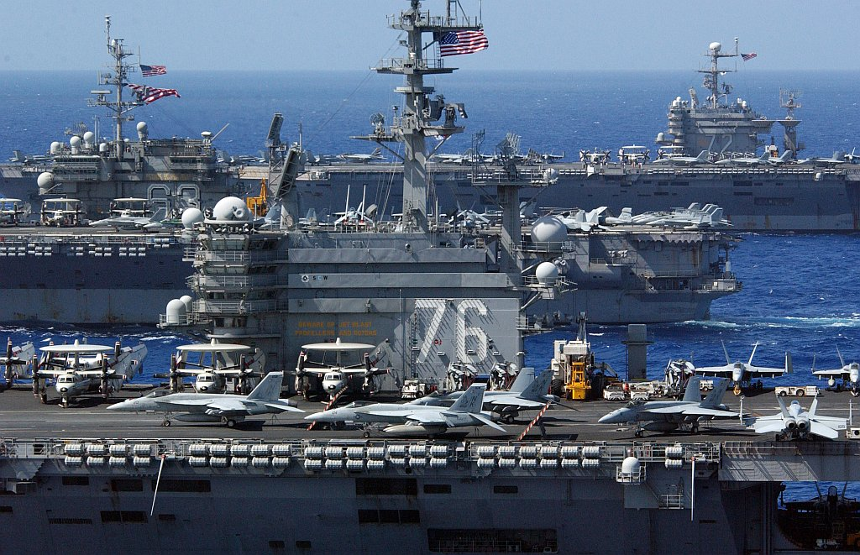

The Navy Hotline provides an opportunity to report significant cases of fraud, waste and mismanagement.

