Carrier Wing FIVE
Welcome to Iwakuni Japan Check List

Congratulations on your orders to Iwakuni, Japan! We want to personally welcome you and let you know we are looking forward to your arrival. The purpose of this welcome aboard checklist is to make your transition to Japan as smooth and stress free as possible.

This checklist is lengthy and has a lot of information. The intent is not to bog you down with details, however, the steps are prioritized in order of importance. To help you, there are details on each task that provide guidance for successful completion. Also, you may call one of the following numbers for more assistance.

Important Phone Numbers
CVW-5 Quarterdeck: DSN 255-1900. Comm 011-81-827-94-1900
Branch Health Clinic phone number: DSN 255-8100. Comm 011-81-827-94-8100
Life threatening / Station emergency: DSN 119 or 911. Comm 0827-21-7700
Anti-terrorism force protection hotline: DSN 253-ATFP(2837). Comm 0827-79-2837

Helpful websites
Rates & Allowances https://www.dfas.mil/
Marine Corps Air Station Iwakuni, Japan https://www.mcasiwakuni.marines.mil/
PCSing to MCAS Iwakuni https://www.mcasiwakuni.marines.mil/PCS-to-Iwakuni/
Housing and Lodging Information https://www.mcasiwakuni.marines.mil/Organizations/Station/Facilities/Military-Housing-Division/
Overseas Allowances https://www.travel.dod.mil/Allowances/

Sponsor
Get in touch with your sponsor early. A good sponsor will make all the difference in explaining how things work and easing your transition. Upon arrival to Iwakuni, Here is what to expect from your sponsor:

- Be a liaison for housing and barracks.
- Assist prospective gains before arrival with needs and essentials
- Help get a PO Box / mailing address set up before arrival (May require Special Power of Attorney (SPOA) and you can only get a PO Box if you have a Dependent Entry Approval (DEA).
- Sign up for Welcome Aboard Orientation brief (mandatory). Spouse and dependents 13 and older are also required to attend.
- Should help drive you around.
- Should help find a car to buy.

**For flights **

Be sure to have your Admin communicate early and often with NAVPTO about getting you and your family flight reservations. The Patriot Express flight from Seattle, WA to Iwakuni leaves Seattle on a Thursday and arrives in Iwakuni on Friday afternoon. If you’re having issues with flights, pass that info to your sponsor.

WELCOME ABOARD CHECKLIST

____ Email your sponsor and introduce yourself. In your e-mail send all of the information listed below.

____ Alternate Contact information (work/home e-mail)

____ Current U.S. mailing address and phone numbers

____ Marital status

____ Family members or pets that will accompany you (i.e. names, ages, breed and size)

____ Spouse’s email address

____ Estimated date/time of arrival at MCAS Iwakuni for yourself and family.

____ Dependent Entry Approval (DEA)/Command Sponsorship – Please send your DEA request to iwakuni.s1manpower@usmc.mil as MCAS Iwakuni does not use Naval message traffic.

In order to get the DEA you need to do the following:

1. Get a Special Issuance Passport (A.K.A. No-Fee) dependent passport, these are separate from the regular tourist passports. TSC at your detaching command will facilitate this. Do not delay submitting your no-fee passport applications because it takes 6 to 8 weeks to process new passports and mail them to the applicants. Note: You cannot use a “No-Fee” passport for leisure travel.

2. Get Dependent Military IDs (not required for kids less than 10 years of age).

3. Get the overseas screening complete. This is easier said than done. Start this process as soon as you receive your orders. Once signed off by medical route through your chain of command for your CO/OIC to approve.

4. Antiterrorism awareness training certificate. This is required for you and dependent spouse. Complete the training on JKO for your spouse. For you, you can complete on Navy e-learning.

5. Finally, follow up with your Admin/Personnel Office for release of the Dependent Entry Approval message. Throughout the entire process, your CPPA should be helping you and making sure you don’t miss a step. Use them as a resource and ask questions to make sure you understand the process.

____ Hand carry copies of the DEA with you to Japan. If your dependents are traveling separately, ensure they hand carry copies of the DEA as well.

____ Tourist passports - It is highly recommended that you and your dependents all have regular tourist passports. However, do not apply for your dependents’ new tourist passports until they have received their no-fee passports. In the past, having applications for both no-fee and tourist passports processed at the same time has resulted in both applications being cancelled.

____ Pets and Quarantine – The pet process includes the following: 1) Microchip, 2) Vaccines, 3) Fluorescent Antibody Virus Neutralization (FAVN) rabies blood test, 4) Health Certificate, 5) Advanced Notification. https://www.mcasiwakuni.marines.mil/Portals/112/Docs/welcome/MCAS%20Iwakuni%20VTF%20Packet.pdf?ver=hZPeaSlT9HBvxLmpYNgtOA%3d%3d

Contact the Iwakuni Veterinary Treatment Facility for more details.
DSN: 315-253-6471 Comm: 011-81-827-79-6471
Email: IwakuniVTF@gmail.com

VTF Iwakuni does NOT have emergency pet care available, see the clinics below for emergency services.

Fujishima Animal Clinic: Often the first place the base vet refers to when base vet services are not available. They are open from 9:00am-12:00pm and again 4:00pm-7:00pm Mon, Tues, Thurs, Fri. and open 9:00am-11:00am and again 3:00pm- 6:00pm Wed and Sat, Closed Sunday. They will sometimes come in after hours, for established patients, for minor emergencies. They accept credit cards and have a few english speaking employees. Call to make an appointment: 0827-35-6256.

Emergency Vet Clinic in Hiroshima: Hiroshima Yakan Kyukyu Dobutsu Byoin is open every day from 9:00pm-1:00am. Phone number: 082-508-6850

____ BAH and dependents remaining in the U.S. – Basic Allowance for Housing (BAH) is different from Overseas Housing Allowance (OHA), and BAH entitlement requires special authorization while you are stationed overseas. Notify your sponsor immediately if you need BAH for a spouse/dependent that will not accompany you and contact your CPPA for additional information.

PERSONAL PROPERTY

____ Household Goods (HHG) Move - Set up your HHG move for delivery to MCAS Iwakuni. Make sure the destination is correct. Your express shipment will arrive much faster than your HHG move, so plan accordingly. “Non-Temporary” Storage: Long-term storage for stuff you want to leave in the U.S. Be aware that you will not be allowed to accept either your HHG or express shipments until you have been assigned housing or signed a lease in town. Neither shipment can be delivered while you and your dependents reside in the Temporary Lodging Facility.

____ Store your POV – You can ship it here, but that is not advised. You will be responsible for all fees for required modifications to vehicle for Japan standards. The government only authorizes funding for the storage (or shipment overseas) of one vehicle. In order to store a vehicle, you must obtain a vehicle storage authorization letter from your Personal Property Detachment (PPD). Be aware that if you set up your move via http://www.move.mil, even though the webpage asks if you will be storing a vehicle it does not actually help you acquire a vehicle storage authorization letter. The vehicle storage authorization letter allows you to store the vehicle in a government sponsored storage facility. If you wish to store your vehicle at a location other than the authorized sites near your current permanent duty station, ask your move counselor very specific questions about reimbursement and subsequent travel to Japan. You could end up paying significant out-of-pocket fees. Keep all of your storage paperwork; you will need it upon return to the U.S.

BEFORE YOU DEPART FOR JAPAN

____ Arrange Temporary Lodging -Your sponsor will assist with Temporary Lodging Facilities (TLF). Inform your sponsor if you’ll need a room at the TLF and they can make your reservation for you. A flight itinerary is required to make the reservation. Single and unaccompanied sailors will go to the barracks.

____ Power of Attorney (POA) – Acquire special and/or general POAs as necessary for your family at your base Legal Office.

___ Update Drivers’ Licenses and Important Documents – You must have a current driver’s license to obtain a SOFA drivers’ license to drive in Japan. If your license will expire during your tenure in Japan it is much easier to get a new license while in the U.S. than overseas.
Below is a list of items you should hand-carry on the airplane:

CRITICAL ITEMS TO HAND CARRY TO JAPAN

____ Medical and dental records (dependents as well; if allowed, most military facilities will mail.)

____ All pet documentation

____ Copy of orders

____ Copy of DEA

MAKE THE TRANSITION EASIER

____ Flight arrival information - Be sure to tell your sponsor when your flight (and your family’s if traveling separately) arrives in Japan so that they can plan the transportation process depending on arrival method. If you are having any travel issues please let your sponsor know. Once you receive your flight itinerary email it to your sponsor.

____ If you are traveling with pets, please refer to Iwakuni Veterinary Treatment Facility Guide to Bringing Pets to Japan (link below). Ensure all travel arrangements are reserved and scheduled prior to leaving for Japan. Bringing pets to MCAS Iwakuni Japan is discouraged. Pets may limit your options for housing and will not be a consideration when making housing assignments if inventory is limited. Many landlords off-base will also not rent to families with pets. Travel with pets to and from Iwakuni may also require inconvenient special arrangements and expensive fees. Keep in mind when you later transfer from Iwakuni, between the months of May through September (heat) and November through February (cold) there are weather advisories that will severely limit the flights that are available to you. If the requirements have not been met or completed accurately, your pet(s) could require a 6 month quarantine at the base kennel, with only a potential of $550 reimbursable for quarantine fees.
https://www.mcasiwakuni.marines.mil/PCS-to-Iwakuni/Pets/

____ Housing Availability & TLA – Contact MCAS Family Housing at DSN: 315-253-5541 or
COMM: 011-81-827-79-5541. Email: iwknfamilyhousing@usmc.mil
https://www.mcasiwakuni.marines.mil/Organizations/Station/Facilities/Military-Housing-Division/Military-Family-Housing/

After completing the Welcome Aboard Brief head over to housing to apply for housing. Often the wait isn’t that long. While you’re staying in the Temporary Living Facility you’ll receive Temporary Lodging Allowance (TLA). This is an allowance that pays for your room(s) and additional expenses. You’ll need to bring your room receipt(s) to your CPPA to receive reimbursement. The CPPA will submit to TSC Yokosuka for processing. The money will post to your account that your normal paychecks go to. This will need to be done every 10 calendar days until you leave the TLF.

____ Iwakuni Medical & TRICARE Overseas: Medical care onboard MCAS Iwakuni is provided by the Naval Branch Health Clinic Iwakuni. Services are rendered by either the Family Medical Home Port (FMHP) Team or assigned Unit Medical Departments. Installation services are limited to routine outpatient care, labor & delivery unit, and routine dental. All urgent and specialty services are referred to either local economy facilities or Naval Hospital Yokosuka.

https://www.mcasiwakuni.marines.mil/Organizations/Naval-Family-Branch-Clinic-Iwakuni/
Branch Health Clinic phone number: 011-81-827-94-8100

____ Enrollment in TRCARE: The following are steps to be completed in order to receive care while stationed at MCAS Iwakuni:

____ a. Upon arrival, you and your dependents MUST be enrolled in the TRICARE Overseas program. This can be conducted by enrolling online at https://tricare.mil/ or by calling comm: +81-98-970-3199 or DSN: 315-645-3199. You and your dependents cannot be placed in for any referrals or be seen for urgent care if not enrolled in TRICARE Overseas.

_____ b. You and your dependents must check in with Iwakuni Medical in order to establish a patient/provider relationship with an assigned Primary Care Manager (PCM) for care. Failure to check-in may result in delayed care.

_____ c. All dependents will check in with the FMHP Team located within the Branch Health Clinic Iwakuni on the second floor. All dependent care is provided by the FMHP team.

_____ Urgent/Routine Care on MCAS Iwakuni Installation: Routine care is conducted within the Branch Health Clinic Iwakuni from 0730-1600 Monday through Friday. Routine care consists of sickcall, optometry, dental, and all ancillary services. Urgent care needs during business hours are to be relayed to the PCM first who will coordinate ongoing care with the clinic Duty Corpsman. Additionally urgent care needs after working hours/weekends will be conducted via Nurse Advice Line at commercial: 0066-33-821820 or DSN: 888-901-7144.

______ Urgent/Routine Care Outside MCAS Iwakuni Installation: If urgent or routine care is required outside of the installation for any TRICARE Overseas eligible member, International SOS (ISOS) and TRICARE Overseas will provide care and referrals via TRICARE authorizations no matter the location of the member within the Asia-pacific region. This can be conducted by the member or family member by calling ISOS/ TRICARE overseas Singapore at comm: +65-6338-9277 or by downloading the ISOS app “My Care Overseas”. App can be used to call ISOS, chat with an TRICARE Overseas representative, receive referrals, track referrals, track appointments, and request any and all other assistance with care or payment.

_____CELL PHONE PROVIDERS in Japan

US:
SPRINT
T-MOBILE
GOOGLE-FI
JAPAN:
DOCOMO
SOFTBANK
YAHOO MOBILE
AU
RAKUTEN
Y-Mobile

____ Newcomer’s Orientation “Welcome Aboard” (WA) – is mandatory in accordance with MCBJO 1754.12. Attendance at WA must be confirmed prior to Iwakuni Pass and ID issuing a SOFA POV drivers’ license (USFJ-4). To sign up for the WA or to get more information, contact your sponsor. The WA is held every Monday from 7:30 AM – 3:30 PM and includes the SOFA driving class. If the Monday falls on a holiday, it will be held on the following Wednesday. Civilian attire is appropriate to attend WA.

____ Driver’s License Class – Get the driver’s class done ASAP after getting here. It’s held every Monday. Ensure prior to departing from the states, your state issued drivers’ license is valid and in good standing. If you think you have a military exemption allowing your driver’s license to be valid passed expiration, contact your state’s Department of Motor Vehicles to confirm that is the case.

____ Schools – MCAS Iwakuni Schools: For each school, children can be registered, and you may contact the following schools at MCAS Iwakuni can via the following websites: https://iwakunims.dodea.edu/school-contacts and https://iwakunims.dodea.edu/school-registration.

It is recommended to enroll your children in school, Child Development Center or the School Age Care Center as soon as possible. See the below links for enrollment and information about the facilities.

M.C. Perry High School: Serves military connected students in grade 9-12. DSN: 315-253-5449 or COMM: 011-81-827-79-5449, or https://mcperryhs.dodea.edu/

Iwakuni Middle School. Serves military connected students in grade 6 to grade 8. DSN: 315-253-6382 or COMM: 011-81-827 79-6382: https://iwakunims.dodea.edu/

Iwakuni Intermediate School. Serves military connected students in grade 3 to grade 5. DSN: 315-253-3168 or COMM: 011-81-827-79-3164: https://iwakuniis.dodea.edu/

Matthew C. Perry Primary School. Serves military connected students in Sure Start to grade 2: DSN: 315-253-3327 or COMM: 011-81-827-79-3327. https://mcperryps.dodea.edu/

School Age Care Center
https://iwakuni.usmc-mccs.org/marine-family-support/child-youth/school-age-care

____ MCAS Iwakuni Child Development Center (CDC): The CDC is designed to meet the individual developmental needs of eligible children, by offering quality childcare for infants and children ages 6 weeks to 12 years old, from 0600-1800. This program provides low adult-to-child ratio support to provide quality experiences for young children. The CDC in MCAS Iwakuni is located in Buildings 635, 636, 637, and 9540. The cost ranges and is contingent on your child’s age, duration of care that is required, and your military pay grade. Hourly care is “Space-A” basis, while regular-hour child care requires enrollment. Depending on the time of year, there is a potential waitlist, so it is strongly recommended to register your child/children 4 to 6 weeks prior to your arrival to Iwakuni, Japan. For additional information, you may contact them by phone via, COMM: 011-81-8027-79-5584, DSN 253-5584, or the hourly care number at 011-81-0827-79-7353. The CDC’s website is:
https://iwakuni.usmc-mccs.org/marine-family-support/child-youth/child-development-centers

____ Banking, ATMs and Cash – There are two banks on base: Navy Federal and Community Bank. The only drawback with Navy Federal is that getting Yen from them is expensive. Part of the deal they had to sign to get a branch on base was to be less competitive than the Community Bank when exchanging dollars to Yen. (Non-compete clause). Other than the non-compete clause, Navy Federal here works just like in the U.S. and is the way to go. If you sign up for Navy Federal’s active duty checking all of your ATM fees at Community Bank are refunded. Additionally, you can access an ATM at 7/11 convenience stores. Some local establishments do not accept credit cards, so it is important to carry Japanese Yen. Very few Japanese ATMs service American ATM / debit cards. At MCAS Iwakuni there is a Navy Federal Credit Union and a Community Bank operated by Bank of America.

____ Buying a car in Japan – You’ll need the following before you can purchase a vehicle:
1. A valid U.S. Military / DoD civilian dependent ID card
2. A valid U.S. state driver’s license (with motorcycle endorsement if applicable)
3. A U.S. Forces Japan SOFA driver’s license
4. PCS orders
5. Basic Riders Course Motorcycle Safety Card at minimum (motorcycle riders only)

Once you’ve met all the above requirements you can buy a car. Cars are relatively cheap and folks who are leaving are required to get rid of their cars before they check out. During Welcome Aboard Orientation they discuss car buying requirements, Fleet and Family Support Center has resources, and talk with your sponsor about what’s best for you.

____ Motorcycle Riders - Most motorcycle riders with stateside bikes do not bring them over due to extensive costs in passing Japanese inspections. Buying a motorcycle is not that much harder than a car, except the costs are a bit more. For more information contact the Lead Motorcycle Trainer for the base at IWKN_SMBIwakuniSaf@usmc.mil

____ Vehicle Registration - All personnel assigned to MCAS Iwakuni must register privately owned vehicles (POV) and motorcycles with the Provide Provost Marshall Office (PMO)’s Pass and Registration Office (Bldg. 608). There may be additional requirements, such as paying the annual state road tax, secondary insurance requirements, that may be required prior to obtaining your registration sticker.

____ Weapons - Do not hand carry any knives or weapons to Japan. Japan has very strict laws about knives and swords (i.e. ceremonial swords), and they will be confiscated at the airport.

____ Iwakuni Altitude App – This app is available in the apple app store as well as on google play. It has information for events and trips, news and information, and travel guides. https://iwakuni.usmc-mccs.org/more/iwakuni-altitude-app

IWAKUNI TRAVEL

Iwakuni and the surrounding areas offer a lot of travel opportunities and sites to visit. Here are a few highlights.

Kintaikyo “Kintai Bridge” (12 minutes from main gate)
The Kintai Bridge is a 200-meter wooden bridge comprising of 5 arches with ornate woodwork dating back to the year 1673. There is plenty of parking to the area beneath the bridge and a couple of food tents in case you’re hungry. On the other side of the bridge is Kikko Park and a couple of ice cream shops. It costs yen to cross the bridge and you get the ticket at the entrance of the bridge. You can also combine the bridge ticket with a ticket up to Iwakuni Castle.

Iwakuni Castle (12 minutes from main gate)
The current Iwakuni Castle is a replica built in 1962. The original was built from 1601 to 1608 and the foundation to the original castle is close to the replica. There are two ways to access the castle. The first is hiking up a paved trail (see Iwakuni Castle Hike section) or the second way is parking at the Iwakuni Castle Ropeway parking lot and taking the ropeway up the mountain. The views from the top of the castle are stunning and worth the trip.

Tzusu Beach aka “Glass Beach” (17 minutes from main gate)
A smaller beach with little individual inlets great for finding sea glass and all the shells you could want. There is also a playground! The turn is easy to miss, so be on the lookout! It will be on your left. When you pull in, it looks like you are at some type of housing complex. Keep driving to your right and you’ll see the parking and beach appear.

Yuu Beach (24 minutes from main gate)
Yuu beach is a “commercial” type beach with a large, free parking lot. It has beautiful views of palm trees, bright blue water, and mountains. This beach is very clean with restrooms, vending machines, and other food options during peak beach season! The Japanese are very into their sun protection, so don’t be surprised when no one is wearing a bikini! In fact, most Japanese are covered head to toe.

Miyajima
Take the ferry over to Miyajima (you can either drive or take the train to get to the ferry). If you drive, you will need to pay to park (around 1000 yen for close parking), and then buy ferry tickets from an automated machine. You can hike Mt. Misen, try all sorts of street food, feed the deer, see the sights, visit the aquarium...Miyajima is an island to visit again and again. It is also home to the large Torii gate, and the Itsukushima shrine. The shrine does cost

Access to Iwakuni – There are numerous ways to travel to and from Iwakuni. This is a flow chart from the three main international airport hubs in Tokyo, Osaka and Fukuoka to Iwakuni.
https://www.mcasiwakuni.marines.mil/Portals/112/Site%20Images/about/access.jpg?ver=2020-02-18-235828-800

Living in Japan tips: Make sure to shop around both on and off base, many items such as groceries, household cleaners and hygiene products could be found cheaper out in town. For example: your average body wash on base costs around $5; off base, a similar body wash costs around 300 yen, or around $2.09. Not everything will fit this shoe though!

IMPORTANT PAGES AND CONTACTS

Facebook can be a blessing and a curse. Here in Iwakuni, it is THE place to find out all you need to know. Unfortunately, it can also be the place where you find out things you didn’t want to know. Below are the pages we recommend you join (depending on your interests!) to follow and search for all the things you need to know to live here. Yes, we know there are more, but these are the gems, not the junk. Click the Group for a direct Facebook link.

Facebook Pages of Interest

MCAS Iwakuni Classifieds and information

Iwakuni Travels

Iwakuni Off-Base Living

CVW-5 Ombudsman

Important Contacts

CVW-5 Military & Family Life Counselor

The Military and Family Life Counseling program supports service members, their families and survivors with confidential non-medical counseling. Non-medical counseling can help individuals address issues such as improving relationships at home and work, stress management, adjustment difficulties, parenting, and grief or loss.

Valéria Tóth, LCSW
JP: 080-4461-3286
US: 571-532-9654
Valeria.J.Toth@leidos.com

MCCS Personal & Professional Development

The primary mission of Personal and Professional Development (P&PD) is to assist Marines and their spouses in achieving their personal and professional goals. Please scan the below QR code for more information.

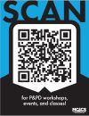

Naval Branch Health Clinic Iwakuni Services
Outpatient Medical Services  - Primary Care  - FlightMedicine  - Ambulance Service  - Optometry  - Occupational Health  - Mental Health  - Audiology  - Pediatrics Care  - OB/GYN Care | Quarterly Visiting Specialty Clinics  - Orthopedics  - Urology  - Neurology  - OB/GYN  - ENT  - Ophthalmology
Additional Services  - Laboratory  - Pharmacy  - Physical Therapy  - Occupational Therapy  - Inpatient OB and Newborn Care  - Hearing Conservation  - Industrial Hygiene  - Environmental Health  - Preventive Medicine  - Health Promotion & Wellness  - Mammo Van (Quarterly) | Early Developmental Intervention Services (EDIS)  - Child Psychology  - Physical Therapy  - Occupational Therapy  - Speech Therapy

Emergency Care
The clinic does NOT contain an Emergency Room or an Urgent Care Center, however, clinic personnel may respond to medical emergencies on base. The clinic relies on local Japanese facilities or the Naval Hospital for all higher levels of emergency care and will transport patients to an appropriate facility immediately when necessary.
Call your local emergency services number or go immediately to an ER.
Enrolled in a TRICARE Prime plan?
Contact your primary care manager within 24 hours or the next business day after you receive emergency care.

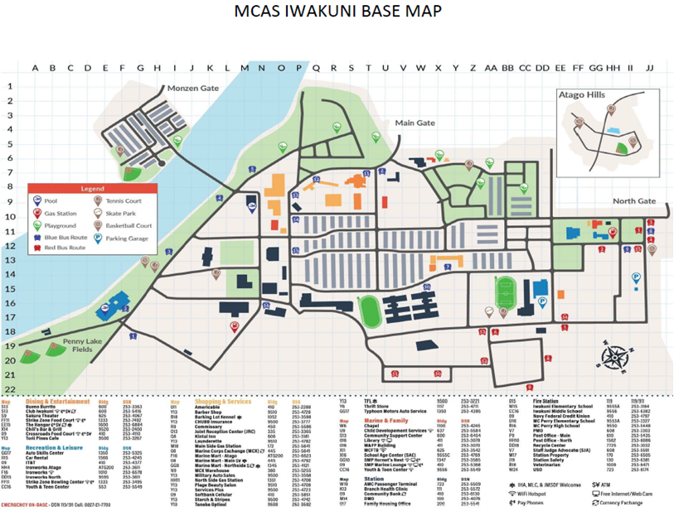
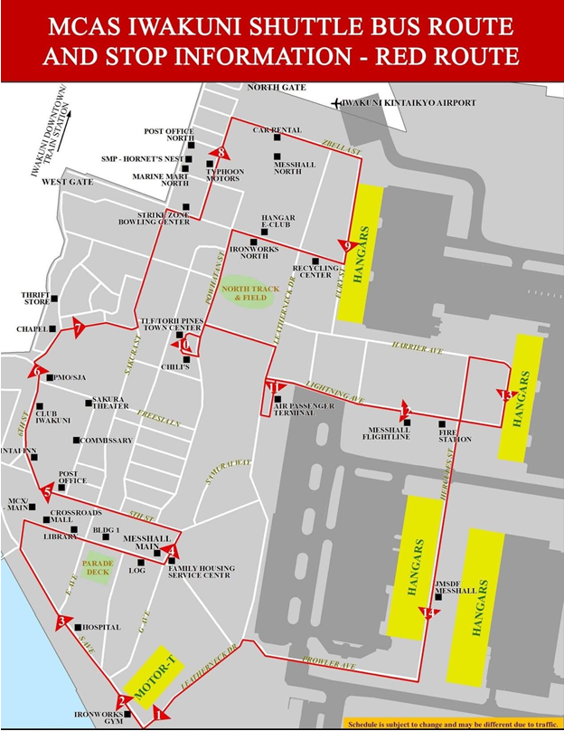

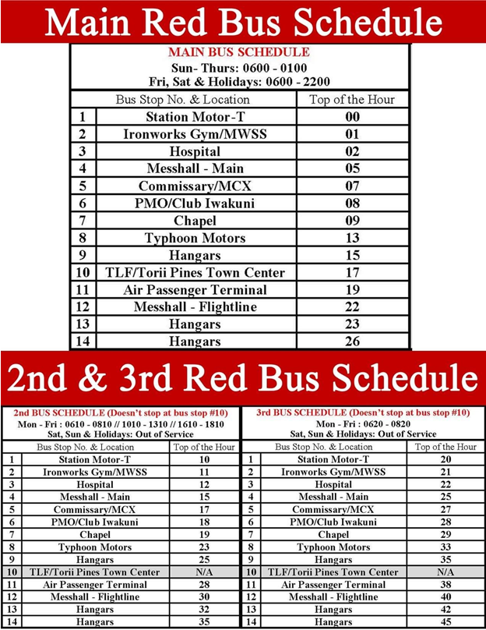
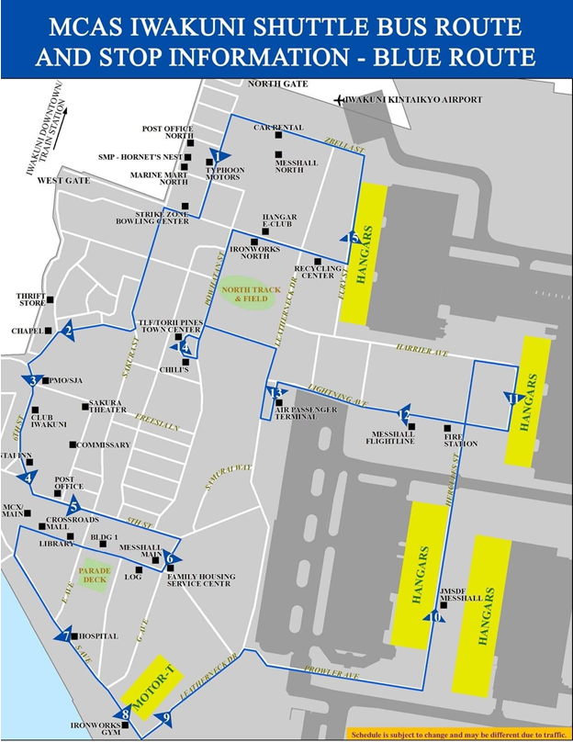

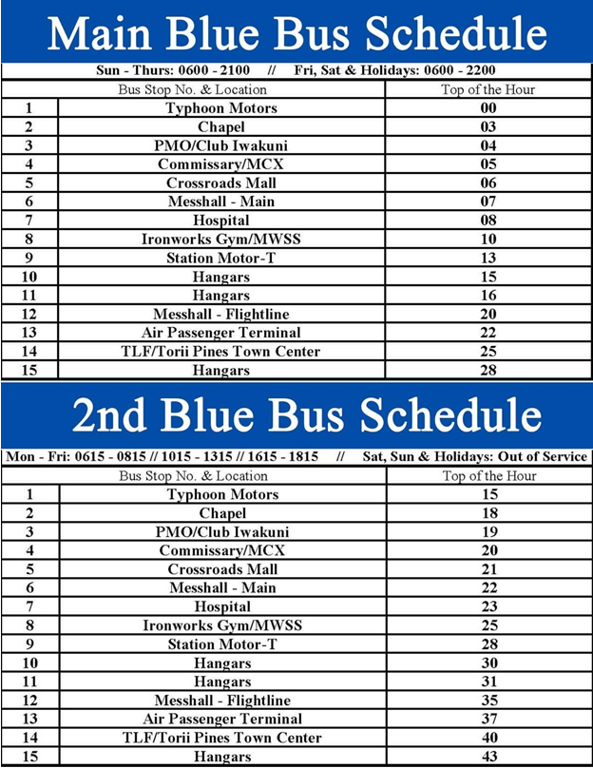

BASE GALLEY, MCX AND COMMISSARY HOURS OF OPERATIONS

GALLEY:
Weekdays:
Breakfast | 5:30 – 7:30 a.m.
Breakfast Snack Line | 7:30 – 8:30 a.m.
Lunch | 11 a.m. – 1 p.m.
Dinner | 4 – 6 p.m.
Weekends/Holidays:
Breakfast Brunch | 9 a.m. - noon
Dinner Brunch | 3 – 5 p.m.
Night Meals (provided to meal card flight line personnel at the Flight line mess hall
Sun - Thurs. | 10:30 p.m. – 0:30 a.m.

CROSSROADS:
Daily: 7:30 a.m. – 8:30 p.m.
MCX:
SUN-THUR, & HOL: 8 a.m. – 8 p.m.
FRI & SAT: 8 a.m. – 10 p.m.
COMMISSARY:
SAT & SUN: 11 a.m. – 6 p.m.
MON: CLOSED
TUE-FRIDAY: 10 a.m. – 7 p.m.

